YUKI algorithm

The YUKI algorithm's first idea is to create a local search area centred around the best solution found so far $X_{best}$, with the area's size determined by the distance between this point and the MeanBest${ X}_{MeanBest}$. represents the centre of the cluster of the best points. The local boundaries $LT$ and $LB$ are calculated using the following expression:
$D=\left|X_{best}-X_{MeanBest}\right|$ (1)

$LT=X_{best}+D$ (2)
$LB=X_{best}-D$ (3)
The YUKI algorithm proposes two concepts to enhance solution quality and exploration. Firstly, partitioning the population into two groups; one to explore beyond the local search area and the other to focus on searching within it. Secondly, generating a random distribution of points within the local search area for exploration to find solutions beyond it. Let $X_{Best}$ denote the vector containing the problem’s variable values that correspond to the best fitnesses at iteration t. Let $X_{MeanBest}$ denote the mean value of the Best Points vector, and let $LT$ and $LB$ denote the boundaries of the local search area.
The YUKI algorithm proposes to partition the population into two groups. One group is tasked with exploring the search space beyond the local region, while the other focuses on searching within the local region. The number of individuals in each group varies linearly; in the initial stages of the algorithm, more individuals are allocated to exploring the search space beyond the local region, while more individuals are dedicated to searching within the local region as the iterations progress. In the improved YUKI algorithm, this technique is replaced by a simpler version where the rate is constant thought out the iteration, and its value is set by the user. This parameter is named EXP for exploration rate, and its value is between 0 and 1, indicating the portion of the population dedicated to exploration.
The third concept of the YUKI algorithm involves creating a distribution of solutions within the local search area. The chosen points are then utilized for exploration to generate the final solutions outside the local search area. In the improved YUKI algorithm, the exploration is based on a simpler yet more efficient technique that uses the distance between the locally generated points and the best historical points, as opposed to the unique direction exploration strategy in which the position of all the exploration population is calculated based on the position of $X_{MeanBest}$ multiplied by the parameter of the random integer. The new strategy does not contain that parameter, it simply expressed the distance of each local point by its corresponding best historical point as is Eq 4. This allows the distribution of the solution in multiple directions, which allows better coverage of the search space.
$E^{i}=X_{loc}^{i}- X_{best}^{i}$ (4)

Where $X_{loc}^{i}$ denotes the chosen local solution, and $X_{best}^{i}$is the historical best position found that corresponds to this particular point. This distance $E^{i}$ is used to set the reach of the exploration range for this particular point. The new solutions are calculated using the following equation:

$X_{new}^{i}=X_{loc}^{i}+ E^{i}$ (5)

The algorithm directs the rest solutions to look around the search center using the following equation, with $F^{i}$ is the distance from the selected local point to the absolute best solution, where rand is a random value between 0 and 1 used simultaneously for all design variables.

$F^{i}=X_{loc}^{i}-X_{best}$ (6)

$X_{new}^{i}=X_{loc}^{i}+rand× F^{i}$ (7)

The following points discuss the theory of the suggested algorithm.

- The process of restating the exploration spread from a smaller area at each iteration facilitates coordination of the exploration effort across various dimensions.
- The multiplication of the MeanBest value by a random integer generates a pulsating effect that is crucial in suggesting distinct solutions each time. This strategy also helps broaden the scope of the search. Higher values of this integer provide an advantage in exploring problems with multiple local optima. Slowly focusing the search around the Best point:
- The gradual convergence of the search towards the Best point decreases the size of the local search area, thereby allowing for more accurate identification of refined fitness values.
- The goal of the algorithm can be expressed as minimizing the distance between MeanBest and Best: Minimizing the distance between the centre of the best points cloud and the position of the global best point will minimize the size of the local search space.
- Sufficient global search space coverage prevents the collapse of the local search.
- New best solutions found outside the local search drastically increase its size in the next iteration.
- Continuous MeanBest updating maintains dynamic search and variation in local search area sizes in all dimensions.

Yuki algorithm pseudo-code
$$Load the search parameters$$
$$Initiate the population X$$
$$Evaluate the fitness$$
$$Calculate the X_{MeanBest} and X_{best}$$
$$for K=1 to K_{max}$$
$$Calculate the local boundaries$$
$$Generate the local population randomly$$
$$if rand< EXP ( EXP=0.7)$$
$$Calculate the exploration solutions$$
$$else$$
$$Calculate focus solutions$$
$$end$$
$$update the X_{MeanBest}$$
$$update the{ X}_{best} if better solutions are found$$
$$end$$
$$return { X}_{best}$$

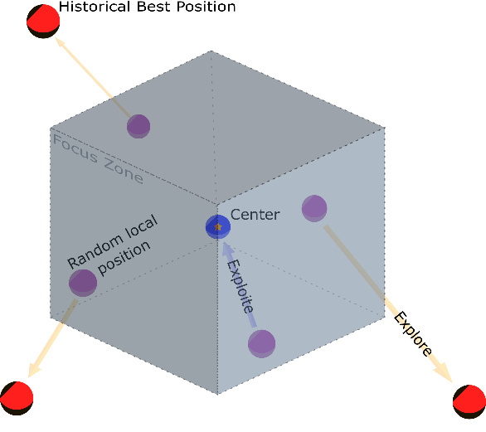
Illustration of the focus zone exploration strategy

